Requirement 1 – Basic Renderer
Etc.

Requirement 2 – Logging
Etc.

Requirement 3 – Conformance
Etc.

Requirement 4 – Tags

Blank lines

Heading

Paragraph

Unordered List

Ordered List

Definition List

Blockquote

Centred Text
Test passed.

Tests Id | Tested by | Most Recent Test | Pass/Fail | Details
acc4-8-0001 | Elpida Kyriakou | 05/06/2009 | Pass
acc4-8-0002 | Elpida Kyriakou | 05/06/2009 | Pass
acc4-8-0003 | Elpida Kyriakou | 05/06/2009 | Pass
acc4-8-0004 | Elpida Kyriakou | 05/06/2009 | Pass
acc4-8-0005 | Elpida Kyriakou | 05/06/2009 | Pass
acc4-8-0006 | Elpida Kyriakou | 05/06/2009 | Pass
acc4-8-0007 | Elpida Kyriakou | 05/06/2009 | Pass
acc4-8-0008 | Elpida Kyriakou | 05/06/2009 | Pass

Screenshot

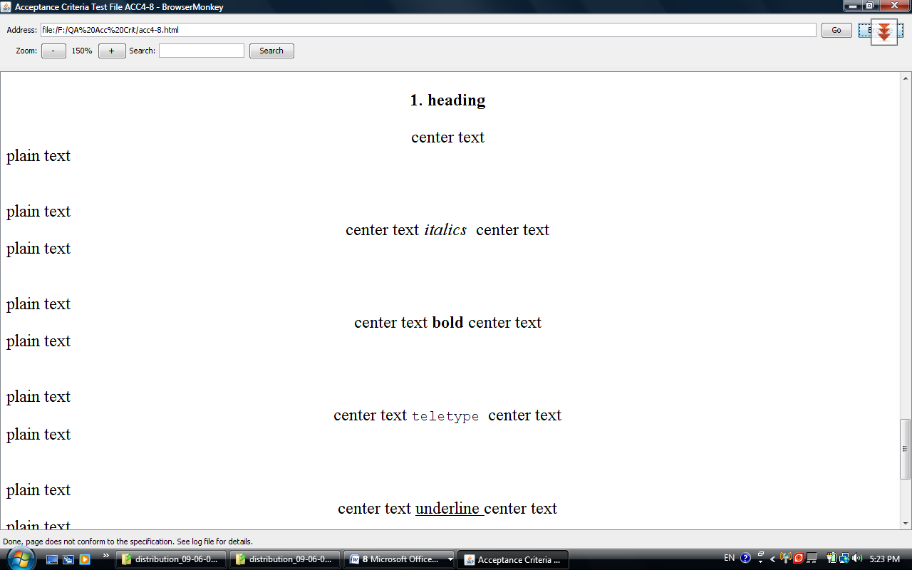

Pre-formatted Text

...and the rest

Requirement 5 – Tables

...and the rest

